**Transcript of Lesson 3**

Slide 2: Explain the table of contents

Slide 3 & 4: Skipped both as already shared with them the video about downloading and installing python.

Slide 5: started with introducing what IDLE and CMD are.

**What is IDLE?**

Idle stands for integrated development and learning environment. IDLE provides a platform which makes it easier to write, run and check for errors in python code.

Every language has its own IDE’s. Python also has many IDE’s that are Python’s built-in editor such as IDLE Shell editor, PyCharm, Visual code, Jupiter etc.

The one we are going to use in now is IDLE shell. We are using it because It is beginner friendly, simplest to use.

Then went through these points given below:

2. The **IDLE Python shell** is an interactive interface within IDLE where you can type Python commands and see the results immediately.

3. It’s helpful for testing small pieces of code without needing to write a full script.

4. It’s great for beginners to practice and see real-time results.

**What is CMD?**

Cmd is command line interface. It runs system specific commands. We communicate to our system using commands instead of using graphical interface.

**How to Open IDLE:**

* **Windows**: We have to search for "IDLE" in the Start menu and open it.

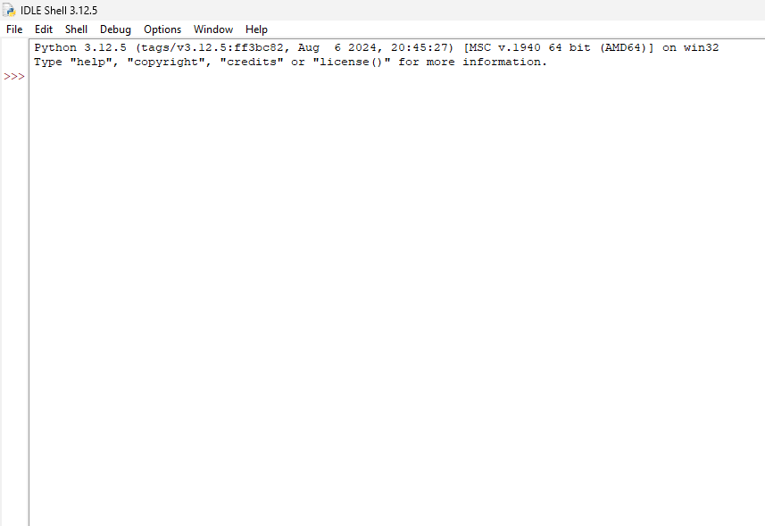A window like this will appear

We call it IDLE Shell this works just like CMD, but specifically for Python. Here we can type our code at a time and see the result instantly on the same window.

**How to write a code in IDLE Shell?**

To print display your name type

 Output:

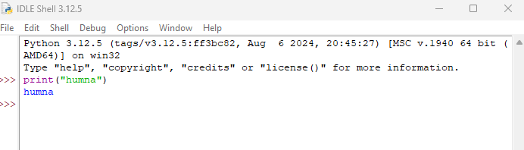On the whole it will look like this

Don’t worry if it seems difficult we are just looking at how to use IDLE Shell for now.

**How to open IDLE Script mode?**

Script is also use for writing a code. We can write longer programs and can save it with .py extension, but in order to view its output we have to first save it and then run it pressing F5

**How to write a code in Script mode?**

You have to click on **File** (in the top left corner) and from there select **New File. Script module will open**

After writing your code you have to save it .

Press **Ctrl + S (meaning Ctrl and S together)**

After that a window will appear asking you about where to solve this file with **extension .py**

Save it wherever you feel like saving it

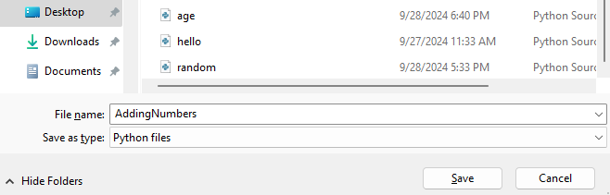

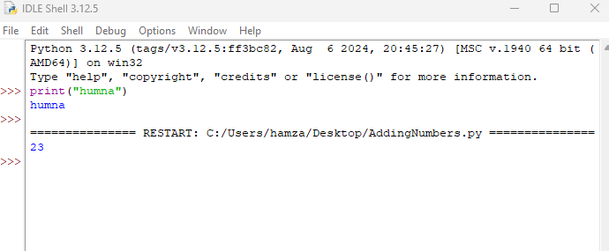Run it by pressing F5 or using **Run -> Run Module**.. Your output will display on Shell.

23 is the output.

**How to invoke python on cmd?**

* **Windows**: We have to search for "CMD" in the Start menu and open it.
* Type Python
* Python is invoke now
* Type print(“humna”)
* Output = humna

There are some python based commands that we can use in cmd such as for checking

Python version : Type **Python –version (it shows which version is install in my system)**

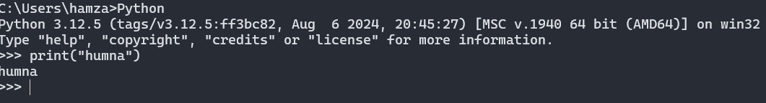Opening Python file: Type **Python filename.py**

**Why we use IDE’s but not Command line interface?**

Because command line interface runs system specific commands it is not possible to write and run longer programs in cmd as it can’t understand programming languages directly. So it is best suited to use IDE’s

**Online Python Interpreter:**

Go to your any search browser and search for **Online python interpreter**. Select programiz.com python interpreter and now you can write your code and run it.

**Compiler VS Interpreter:**

**Question: What is Compiler ? What is Interpreter? and the main difference?**

Answer: Let’s suppose that you have a book, you want to read it and the language in which book is written is Sindhi. You will not be able to understand it so in order to understand the book you need a translator who will translate it for you.

You go to your friend (the one who knows Sindhi) and ask her to translate it for you.

She can go with two approaches to translate the book for you

1. Reading the whole book and then translating it and sharing the translated book with you
2. Translating line by line and read it to you so you can understand and this will continue till the book completed.

Reading the whole book then translating the whole book and then reading it to you will be an example of compiler. Like you are getting the translated book in the end

Translating line by line and reading the translated version to you line by line will be an example of Interpreter.

**So what compiler do ?** It will take the source code (the code you have written) and will translate it into machine language to form executable code (ready to run on our machine)



Source code

Compiler



Executable code



Source code: The code you have written

Compiler: Converting high-level language (our code) into low-level language (Machine language such as 1’s and 0’s

Executable code: The code that is ready to run on any machine without the need of compiler.

Windows executable file will run on any machine that has windows.

Examples: C++ and C are compiler languages

**What Interpreter do?**

Interpreter translates line by line from (source code) low-level to high-level language (Executable code).



Source code



Interpreter

Executable code



Get Next Instruction

Examples: Python and JavaScript are Interpreted languages

**Question to ponder? Which one is slower? Compiler or Interpreter**

Interpreter is more slower as compared to compiler because conversion is taking place line by line so it will be a slower process on the other hand compiler will read the source code and then will convert it at a time so it will be faster.

**What is Syntax?**

Syntax is about rules and instructions that a programmer must follow in order to combine words and generating a code.

Just think of it as a way of writing your essay so that you score higher. If you follow the pattern of essay such as introduction, body and conclusion and then write your essay then you will definitely score more among other students.

So in programming especially **in python syntax are a set of rules that must be follow to write code for the computer to understand and execute it correctly.**

Activity: Here we are doing some practice to know about python syntax

1. Print your name
2. Print your age



1. Create a variable **age=21** ,then concatenate your age with **“my age is”,age** with in **print**



1. Multiply 2 numbers and print answer
2. A number and equation on a white background

   Description automatically generatedStoring 5 in a and print it



1. Create a Variable **name**  and assign it value **“humna”** then print **name**



As you can see in point 5 and point 6

we have a variable name **a** and we are storing the value **5** in **a**

Similarly in point 6, The variable **name** stored the value **humna** in. In variable while storing the value **5**, we didn't use quotation marks. But in 6th point when we were storing a value, in **name** we use quotation marks.

This is because while we are storing a string in a variable. We always use quotation marks but when we are storing integer we do not use quotation marks. So this is how the syntax work in Python. These are the basically rules that we have to follow in order to get our desired output.

Above these are examples of Valid syntax. Now we will look into invalid syntax.

1. Print the variable we didn’t define

1. Extra space before variable

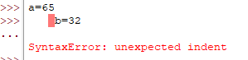

**What is Comment?**

A comment is a part of the coding file that the programmer does not want to execute, rather the programmer uses it to either explain a block of code or to avoid the execution of a specific part of code while testing.

We will continue from here in the next lecture.